**CS-303 Assignment 4**

(25 points)

Q1 (15 points) Draw an expression tree corresponding to each of the following:

1. Inorder traversal is:  x / y + 3 * b / c
2. Postorder traversal is:  x y z + a b – c * / –



1. Preorder traversal is:  * + a – x y / c d

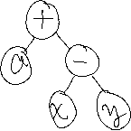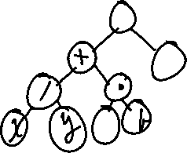

Q2 (10 points) Considered the output of a to_string method below and show the tree that would be built by the following data lines is the binary search tree.



30

15

4

NULL

NULL

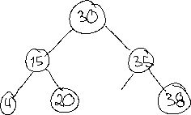

20

18

NULL



19



NULL

NULL



NULL

35



32

NULL

NULL

38

NULL

NULL

**Submission guidelines:**

1. Create a solution document (word or pdf) that contains the trees created for Q1 and Q2

2. Upload your solution document to GitHub.

3. Submit the GitHub link on Canvas by due date.